high level low level risk comparison
low level risk contributed more records then high level
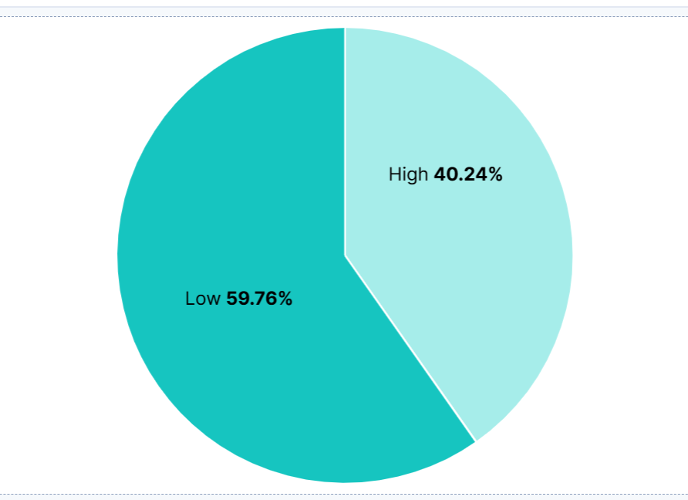
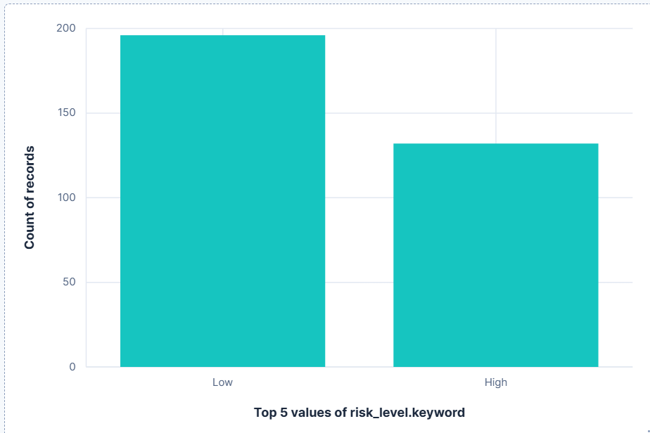
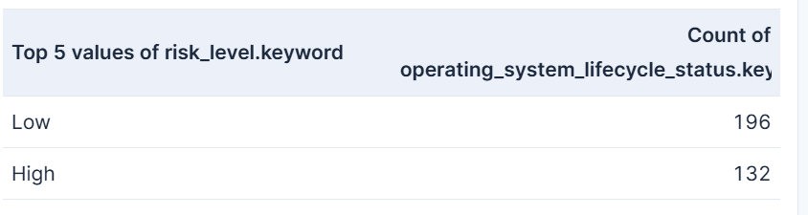

Country wise performance score percentage
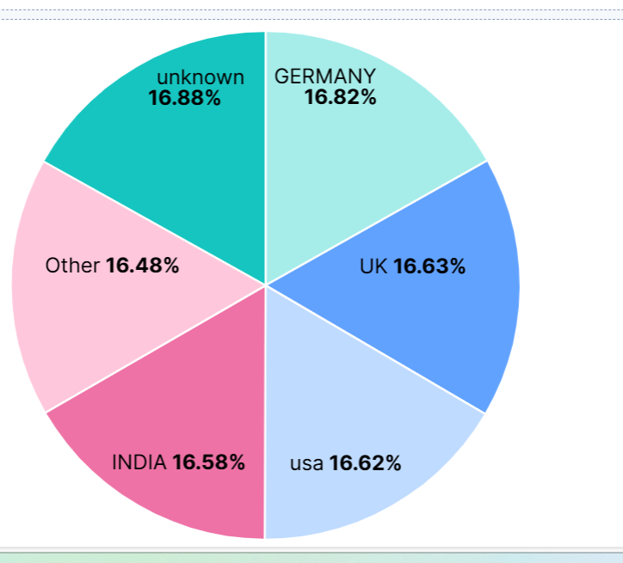

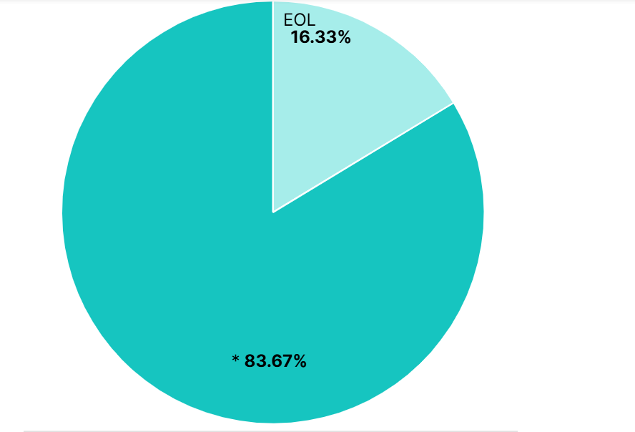
Out of 328 records 67 records(17.17%) contributed for OS life cycle status EOS need to version upgrade of OS or OS migration as per hardware compatinility immediately temporarily try for extended vendor support till upgrade or migration completed

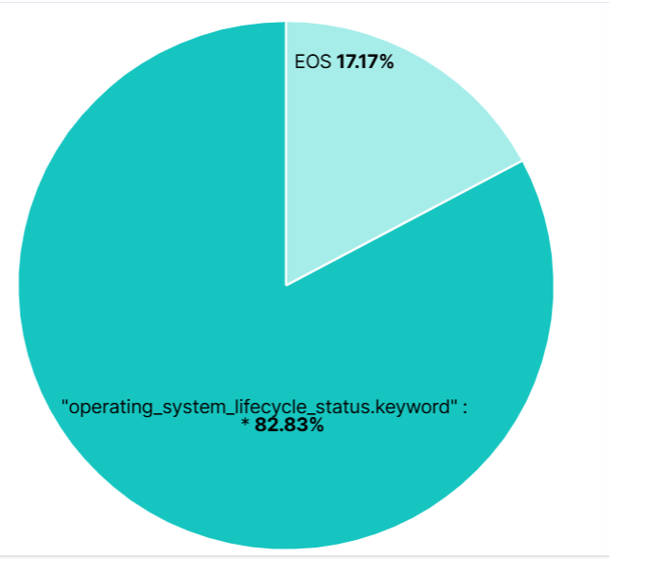
EOS contributed 17.17 %

Final report:
Need to upgrade immediately which has end of life and get extended support temporarily for EOS and need to migrate or upgrade immediately

